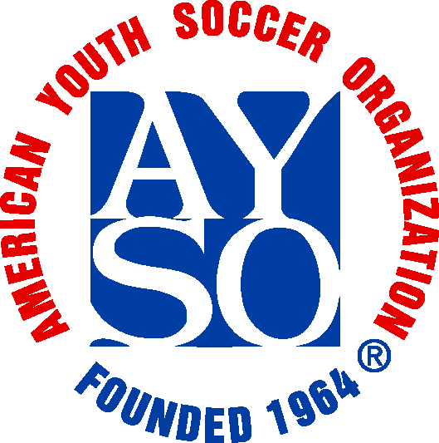
AYSO Region 605
All Star Coaching Application
Statement of Purpose: AYSO Region 605 All Star Team coaches are chosen as the best coaches this region has to offer in coaching ability, behavior, leadership, and importantly in their ability to embrace the spirit and philosophies of AYSO
Division: U19 U16 U14 U12 U10 Boys Girls
Name: Telephone:
Address: Zip:
Email:
Coaching Information:
Years as a Head Coach: Divisions coached:
Years as an Asst. Coach:
Previous All-Star or Select experience:
AYSO Coaching Certification:
U6 U8 U10 U12 Intermediate Advanced National Other
Other training (describe):

Other volunteer positions (Referee, Instructor, etc.):

If selected, you will have the opportunity to coach some of the most talented players in Region 605. We will be intrusting in you the care and welfare of these players plus the long term welfare of our region’s soccer program. It is understood that the Region Board of Directors desire the coaches and each of these players to return the following year to our program in order to share their experiences and skills acquired during the All-Star seasons with other players in Region 605.
_____________________________________________________________________________________
In addition to the above statement, I have read and understood all AYSO Rules and Regulations, Region 605 Rules and Regulations, Region 605 All Star Rules and Regulations and AYSO spirit and philosophies. I understand that all of these Rules and Regulations pertain to the All Star seasons.
Signature:

